Trivenia Sharp welcomed everyone and began the meeting at 8:49 am, Motion to start from Kristen Harper, seconded by Stacey Moat. Motion passes
Secretary’s Report- Approve September and October minutes. Motion to approve by Shae Adamick, seconded by Kerri Kibby.
Treasurer’s Report- Faith Chang reviewed the treasurer’s report attached. Beginning balance as of 11/11/21 was $8,382.23. The 7/8th grade dance after expenses made a profit of $4,475.19!! That makes our current ending balance is $12,488.55. Full Treasurer’s Report attached.
Committee Updates- The 6th grade dance has been scheduled for Friday February 11, 2022. Katie Stroade is heading up this event. Be looking for information for the first meeting in early December.
On Friday December 10th the PTO will be hosting the Teacher and Staff Christmas Luncheon. A sign-up genius will be emailed out by Trivenia Sharp with Volunteer times and items that can be donated.
The Veterans Day Parade is TODAY at 12:45pm. The PTO will be passing out cookies and setting up balloons.
Spirit Nights: The next spirit night is November 15th from 5-8pm. Mention MJH and the school receives a percentage of their sales. Mark your calendars for December 13th at McKenzie’s BBQ from 4-8pm. Mention MJH and the school receives 25% of the sales.
Spirit Wear: During Friday lunches there will be a table set up to sell spirit wear. Signups are available through signup genius. Spirit Wear can also be purchased online through the PTO website.
Sponsorship opportunities: There is a new sponsorship opportunity this year. Email mjhpto1@gmail.com for more details.
Check out the Sign-up genius for:
Spirit wear sales during lunch periods.
Teacher Luncheon on December 10th
A few important dates to remember:
November 12 Spirit wear sales (need volunteers)
November 19 Spirit wear sales
November 23-26 Thanksgiving break
November 29-Dec 2 Grinch Week
November 30 DC Williamsburg Parent Meeting
December 9 December PTO Meeting
December 10 Teacher and Staff Christmas Luncheon
December 13 Spirit Night at McKenzie’s BBQ
Adjourn-Motion from Faith Chang, seconded by Jessie Yeager. Motion Passes- 9:03am
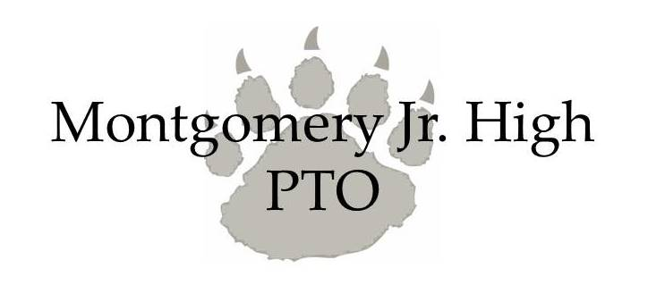

TREASURER'S REPORT
Monthly Banking Activity Summary
2021-2022
November 11, 2021
Beginning balance as of 10/14/21 |  |  | $ 8,382.23
Income:
 | 7th & 8th Grade Dance
 | Ticket Sales |  | $3,309.00
 | Pizza Sales |  | $385.00
 | Drink Sales |  | $461.00
 | Candy Sales |  | $315.00
 | Trinket Sales |  | $971.00
 | Donation |  | $17.00
 | Boo Bag Sales |  | $423.00
 | Donation |  | $100.00
 | Membership |  | $70.00
 | Mum Sales |  | $160.00
 | Petty Cash Deposit |  | $700.00
 | Spirit Wear |  | $2,037.10
 |  | Total: | $17,330.33
Expenses:
 | 7th & 8th Grade Dance
 | Ticket Sales |  | $102.84
 | Pizza Sales |  | $235.00
 | Trinket Sales |  | -$1.09
 | Decoration |  | $227.24
 | DJ |  | $395.00
 | Drink Sales |  | $23.82
 | Boo Bag Sales |  | $202.38
 | Hospitality-Meeting-breakfast |  | $42.45
 | Mum Sales |  | $800.00
 | Paypal Fees |  | $43.98
 | Petty Cash Withdrawal |  | $500.00
 | Square Fees |  | $43.16
 | Spirit Wear |  | $2,227.00
 |  | Total: | $4,841.78
Ending Balance |  |  | $12,488.55
Outstanding checks
 | MHS Floral Ck#1004 |  | $745.00
 | Stephanie Smith Ck#1008 |  | $23.82
 | Current Banking Balance |  | $13,257.37

